|  |  |  |
| --- | --- | --- |
| SCHOOL OF INFORMATION AND TECHNOLOGY | | |
| NAME: Zhaun Gabrielle F. Pasion | DATE PERFORMED: Aug 22 24 | 45/50 |
| Section:IDC2 | DATE SUBMITTED: Aug 22 24 |

# SYSADM1 – Introduction to File Systems in Windows and Linux

# Requirement:

* A virtual machine running Linux and Windows OS

# Instructions:

**Part A: Windows File System**

1. **Open File Explorer:** Click the File Explorer icon on your desktop or press the Windows key + E.
2. **Navigate to your Documents folder:** This is usually the default location for user files.
3. **Create a new folder:** Right-click in an empty space, select "New," then "Folder." Name it "Lab1_Windows."
4. **Create a text file:** Right-click in the "Lab1_Windows" folder, select "New," then "Text Document." Rename it to "info.txt."
5. **Open the text file:** Double-click the "info.txt" file to open it in Notepad.
6. **Type some text:** Write a short paragraph about yourself or the purpose of the file.
7. **Save the file:** Close the Notepad window and save the changes.
8. **Create a subfolder:** Create a new folder inside "Lab1_Windows" called "Data."
9. **Copy the text file:** Copy the "info.txt" file to the "Data" subfolder.
10. **Rename the copied file:** Rename the copied file to "data.txt.
11. Create a folder named "LabFiles" with subfolders for each file type. Use the internet for the resources of the files listed below.

**LabFiles**

* 1. **Text**
     1. large_text.txt
     2. small_text.txt
     3. code.cpp
  2. **Images**
     1. image1.jpg
     2. image2.png
     3. image3.bmp
  3. **Audio**
     1. song.mp3
     2. speech.wav
  4. **Video**
     1. clip.mp4

1. **Check file properties:** Right-click on the "info.txt" file and select "Properties." Explore the General, Details, and Security tabs to understand file attributes like creation date, size, and read-only status.
2. **Change file attributes:** Try changing the file attributes (e.g., read-only, hidden) using the Properties dialog. Observe the changes in File Explorer.
3. **Share the folder:** Right-click on the "Lab1_Windows" folder, select "Properties," and then the "Sharing" tab. Share the folder with a specific user or group, setting appropriate permissions (e.g., Read, Write, Full control)
4. **Create an archive:** Use WinRAR or 7-Zip to create a compressed archive of the "Lab1_Windows" folder.
5. **Extract an archive:** Create a new folder, then extract the created archive into it.

Part B. Create a log report structure

|  |  |  |
| --- | --- | --- |
| **Task** | **Action** | **Observation** |
| Create Lab1_Windows Folder | Right-Click, create a new folder, and rename to Lab1_Windows | New folder "Lab1_Windows" was created. |
| Create a Text File | Create a text file named “info.txt” inside Lab1_Windows folder and add a short paragraph | Text file "info.txt" was created with a short paragraph inside. No need to put the file extension after the name. into.txt.txt -> info.txt |
| Create LabFiles folder and sub folders named Text, Images, Audio, and Video. Add different file formats in the subfolders | Create a folder named LabFiles and subfolders named Text, Images, Audio, and Video. Add different file formats in each subfolder | LabFiles folder was created and Subfolders Text, Images, Audio, and Video are also created. There might be a problem when browsing different files as they have different file formats. I suggest using a single format for easy browsing. |
| Create a Data folder inside Lab1_Windows and copy info.txt and rename it to data.txt | Create a Data folder inside Lab1_Windows . Copy the info.txt file and paste in inside the created folder. Renamed in to data.txt | Data folder is created with the renamed data.txt folder. Content of data folder and info.txt folder are the same. They must hold information related to what the folder is all about |
| Check Properties of info.txt | Surf the properties of info.txt | The generals tab shows the creation, modified and accessed date of the folder. Security tab shows who can access the data and how they can work with it. Details tab shows simplified data like the Generals tab with the order and the computer name |
| Change File Properties | Change file attributes to read-only and hidden | Read only still lets the user edit the text but saves it as another document. The hidden attributes hides the files but still shows the file is the show hidden files option is pressed on the view dropdown |
| Share folder | Change the files sharing options | The shared file lets the shared people read, edit, or have full control of the folder |
| Compress and Extract Folder | Compress Lab1_Windows folder and extract in on another folder | Compress and Extraction is success. However there is an additional file in the Images folder named “Thumbs” and is a Data Base File. |

**Screenshots**



Inside Lab1_Windows Folder

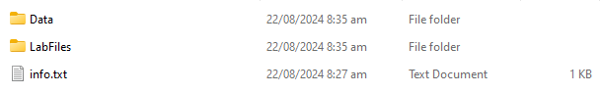

Inside Data folder  
  


Inside LabFiles folder

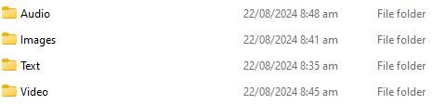

Inside Audio Folder



Inside Images Folder

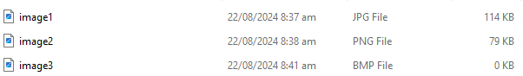

Inside Text Folder

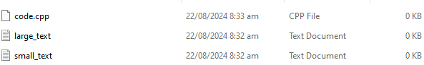

Inside Video Folder



info.txt properties

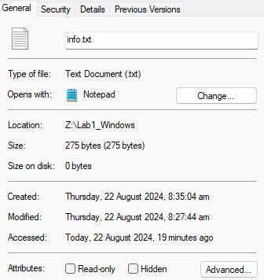 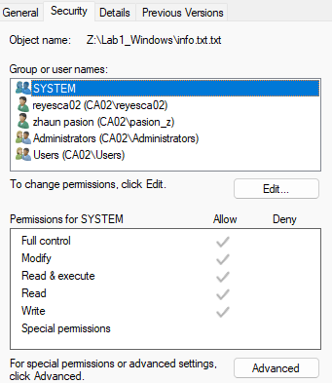 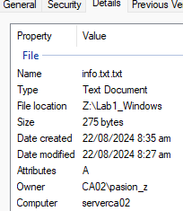

Shared Folder

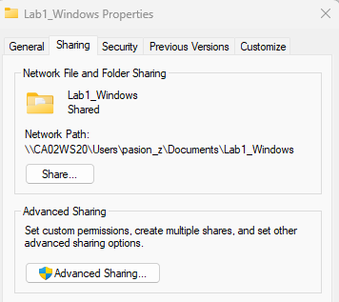 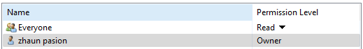

Lab1_Windows.rar



Lab1_Windows.rar Folder





**Cybrary**

